## Part 1

1. Run a query that creates a table named viewer that has the following columns: viewer_id, first_name, last_name, email. Make sure the viewer_id is the primary key and auto increments.

Query:

CREATE TABLE viewer (

viewer_id INTEGER PRIMARY KEY AUTO_INCREMENT,

first_name VARCHAR(45) NOT NULL,

last_name VARCHAR(45) NOT NULL,

email VARCHAR(50) NOT NULL

);

1. Add the following customers:

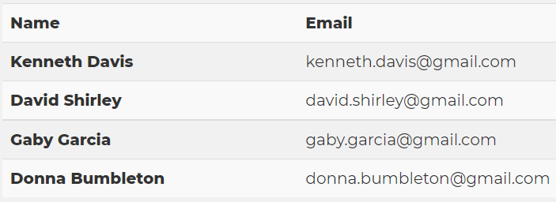

Query:

INSERT INTO viewer (first_name, last_name, email)

VALUES

("Kenneth", "Davis", "kenneth.davis@gmail.com"),

("David", "Shirley", "david.shirley@gmail.com"),

("Gaby", "Garcia", "gaby.garcia@gmail.com"),

("Donna", "Bumbleton", "donna.bumbleton@gmail.com");

1. Run a query to see all the new customers within the database.

Query:

SELECT * FROM viewer;

Results (4 rows returned):

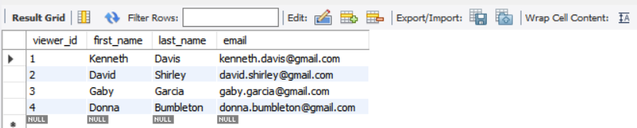

## Part 2

1. Run the following SQL query to add a new table into the database:

CREATE TABLE sakila.StreamingServiceQueue(

queue_id INTEGER PRIMARY KEY AUTO_INCREMENT,

genre NVARCHAR(50) NOT NULL,

filmTitle NVARCHAR(50) NOT NULL,

streamAvailable BOOLEAN CHECK(streamAvailable IN (true, false))

);

Task complete.

1. Next, run the following insert statements to add some data to the Products table:

-- query 1

INSERT INTO sakila.StreamingServiceQueue (genre, filmTitle, streamAvailable)

VALUES ("Movies based on books","The Breadwinner", true);

-- query 2

INSERT INTO sakila.StreamingServiceQueue (genre, filmTitle, streamAvailable)

VALUES ("Emotional","Roma", false);

-- query 3

INSERT INTO sakila.StreamingServiceQueue (genre, filmTitle, streamAvailable)

VALUES ("Campy","To Wong Foo, Thanks for Everything Julie Newmar", true);

-- query 4

INSERT INTO sakila.StreamingServiceQueue (genre, filmTitle, streamAvailable)

VALUES ("Critically Acclaimed","A Single Man", true);

Task complete.

1. Run a query to see all of the films in your Streaming Service queue.

Query:

SELECT * FROM sakila.StreamingServiceQueue;

Results (4 rows returned):

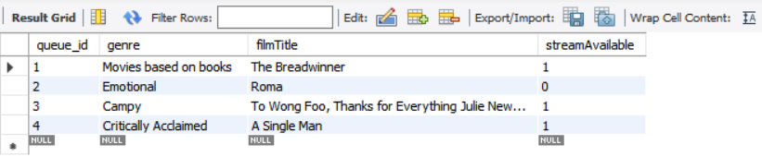

## Part 3

1. Run the following SQL query to add a new table into the database:

CREATE TABLE sakila.WatchedList(

watch_id INTEGER PRIMARY KEY AUTO_INCREMENT,

queue_id INTEGER NOT NULL,

viewer_id INTEGER NOT NULL,

FOREIGN KEY(viewer_id) REFERENCES sakila.viewer(viewer_id),

FOREIGN KEY(queue_id) REFERENCES sakila.StreamingServiceQueue(queue_id)

);

Task complete.

1. Next, run the following insert statements to add some data to the WatchedList table:

-- query 1

INSERT INTO sakila.WatchedList (viewer_id, queue_id)

VALUES (1, 2);

-- query 2

INSERT INTO sakila.WatchedList (viewer_id, queue_id)

VALUES (2, 1);

-- query 3

INSERT INTO sakila.WatchedList (viewer_id, queue_id)

VALUES (3, 2);

-- query 4

INSERT INTO sakila.WatchedList (viewer_id, queue_id)

VALUES (4, 1);

Task complete.

1. Lastly, run a query to see the customer's full name, their email address, and their watch_id as well as the genre and title of the film they watched. The list of customers should be ordered in alphabetical order by their last name.

Query:

SELECT first_name, last_name, email, watch_id, genre, filmTitle

FROM sakila.viewer

JOIN sakila.WatchedList

USING(viewer_id)

JOIN sakila.StreamingServiceQueue

USING(queue_id)

ORDER BY last_name;

Results (4 rows returned):

